MITRE ATT&CK–Based Purple Team Lab – Synopsis

Abstract
This project aims to develop a lightweight, automated system for threat detection and incident mapping, utilizing the MITRE ATT&CK framework. Its primary goal is to streamline the analysis of numerous security alerts by offering a clear, contextual understanding of potential attacks. The solution functions by collecting and analyzing logs from sources such as Windows Sysmon and Linux Syslog, applying detection rules, and then mapping these events to specific attacker tactics and techniques. The system provides an interactive visualization of attack chains on an ATT&CK matrix, prioritizes incidents by severity, and generates reports suitable for compliance purposes. Ultimately, this project facilitates faster and more effective incident response by converting raw security alerts into actionable intelligence..

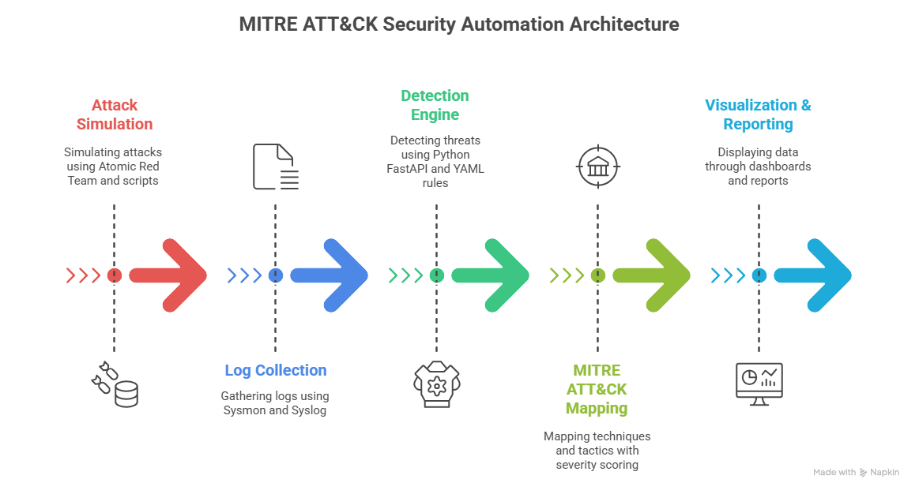

Objectives
The project has several key objectives:
- Automated Detection & Mapping: Automatically detect security events and map them to MITRE ATT&CK tactics and techniques.
- Log Collection & Normalization: Gather and standardize logs from Windows Sysmon and Linux Syslog.
- Severity-Based Prioritization: Assign severity scores to incidents for effective prioritization of high-risk events.
- Interactive Visualization: Present results through an interactive matrix and attack path view.
- ATT&CK-Referenced Reporting: Generate reports referenced against ATT&CK for documentation and compliance purposes.
- Custom Rule Support: Allow for custom detection rules to expand coverage for unique organizational scenarios.

Scope
In-Scope:
- Implementation of selected MITRE ATT&CK techniques:
  - Reconnaissance (TA0043)
    - Technique: Gather Victim Identity Information (T1589)
      - Sub-technique: Credentials (T1589.001)
      - Sub-technique: Email Addresses (T1589.002)
      - Sub-technique: Employee Names (T1589.003)
    - Technique: Search Open Technical Databases (T1596)
      - Sub-technique: DNS/Passive DNS (T1596.001)
      - Sub-technique: WHOIS (T1596.002)
      - Sub-technique: Digital Certificate (T1596.004)
      - Sub-technique: CDNs (T1596.005)
      - Sub-technique: Scan Databases (T1596.006)

Resource Development (TA0042)
    - Technique: Compromise Accounts (T1586)
      - Sub-technique: Social Media Account (T1586.001)
      - Sub-technique: Email Account (T1586.002)
      - Sub-technique: Cloud Account (T1586.003)
    - Technique: Establish Accounts (T1585)
      - Sub-technique: Social Media Account (T1585.001)
      - Sub-technique: Email Account (T1585.002)
      - Sub-technique: Cloud Account (T1585.003)

Initial Access (TA0001)
    - Technique: Content Injection (T1659)
    - Technique: Wi-Fi Networks (T1498)

Execution (TA0002)
    - Technique: User Execution (T1204)
      - Sub-technique: Malicious Link (T1204.001)
      - Sub-technique: Malicious File (T1204.002)
      - Sub-technique: Malicious Image (T1204.003)
      - Sub-technique: Malicious Copy and Paste (T1204.004)
    - Technique: Input Injection (T1056)

Persistence (TA0003)
    - Technique: External Remote Services (T1133)
    - Technique: Create Account (T1136)
      - Sub-technique: Local Account (T1136.001)
      - Sub-technique: Domain Account (T1136.002)
      - Sub-technique: Cloud Account (T1136.003)

Privilege Escalation (TA0004)
    - Technique: Valid Accounts (T1078)
      - Sub-technique: Default Account (T1078.001)
      - Sub-technique: Domain Account (T1078.002)
      - Sub-technique: Local Account (T1078.003)
      - Sub-technique: Cloud Account (T1078.004)
    - Technique: Escape to Host (T1210)

Defense Evasion (TA0005)
    - Technique: Email Spoofing (T1566.001)
    - Technique: Impersonation (T1464)

Credential Access (TA0006)
    - Technique: Brute Force (T1110)
      - Sub-technique: Password Guessing (T1110.001)
      - Sub-technique: Password Cracking (T1110.002)
      - Sub-technique: Password Spraying (T1110.003)
      - Sub-technique: Credential Stuffing (T1110.004)
    - Technique: Forced Authentication (T1187)

Discovery (TA0007)
    - Technique: Network Sniffing (T1040)

Lateral Movement (TA0008)
    - Technique: Internal Spearphishing (T1566.002)

Collection (TA0009)
    - Technique: Input Capture (T1056)
      - Sub-technique: Keylogging (T1056.001)
      - Sub-technique: GUI Input Capture (T1056.002)
      - Sub-technique: Web Portal Capture (T1056.003)
      - Sub-technique: Credential API Hooking (T1056.004)
    - Technique: Audio Capture (T1123)
    - Technique: Screen Capture (T1113)

Command and Control (TA0011)
    - Technique: Data Encoding (T1132)
      - Sub-technique: Standard Encoding (T1132.001)
      - Sub-technique: Non-Standard Encoding (T1132.002)
    - Technique: Data Obfuscation (T1001)
      - Sub-technique: Junk Data (T1001.001)
      - Sub-technique: Steganography (T1001.002)
      - Sub-technique: Protocol or Service Impersonation (T1001.003)

Exfiltration (TA0010)
    - Technique: Automated Exfiltration (T1041)
      - Sub-technique: Traffic Duplication (T1041.001)
    - Technique: Data Transfer Size Limits (T1030)

Impact (TA0040)
    - Technique: Email Bombing (T1498.001)
    - Technique: Defacement (T1491)
      - Sub-technique: Internal (T1491.001)
      - Sub-technique: External (T1491.002)

- Development of backend detection engine with Python (FastAPI + SQLite).
- Visualization of attack chains and tactics through a web dashboard.
- Basic report generation for incidents.

Methodology
- Lab Setup: Configure Windows and Linux virtual machines with Sysmon and Syslog.
- Data Generation: Use Atomic Red Team and custom PowerShell/Bash scripts to create attack scenarios.
- Detection Rules: Write YAML-based rules to detect chosen MITRE ATT&CK techniques.
- Mapping Engine: Implement logic to link detections with ATT&CK tactics and techniques.
- Incident Scoring: Apply severity-based ranking for triage.
- Visualization: Display detections on an interactive matrix or graph.
- Reporting: Generate PDF/HTML reports with ATT&CK references.
- Testing: Validate detections against simulated attacks and fine-tune rules.

Expected Outcomes
This project will deliver:
- A functional detection engine aligned with MITRE ATT&CK.
- A web dashboard displaying mapped attack techniques and their severity scores.
- Sample reports documenting attack simulations and detection coverage.
- Comprehensive documentation of the lab setup, methodology, and results.

Technologies & Tools
- Programming Languages & Frameworks: Python 3 (FastAPI, PyYAML, SQLite, Jinja2)
- Data Visualization: Jinja2 + Bootstrap (React is an optional choice for enhanced user interfaces)
- Log Data Sources: Windows Sysmon, Linux Syslog
- Attack Simulation Tools: Atomic Red Team, Custom Scripts
- Development Environment: VS Code, GitHub, Postman, Docker (optional)

Conclusion
MITRE ATT&CK Security Automation is designed to make threat detection smarter, faster, and more contextual. By mapping real-time detections to adversary tactics and techniques, it helps analysts understand the “story” of an attack and respond quickly. The project is practical, scalable, and aligned with industry practices, making it both academically valuable and industry-relevant.

